EXPT NO: 8 | GENERATION OF SYNTHETIC IMAGES USING A GENERATIVE ADVERSARIAL NETWORK (GAN)
DATE: 2/11/2026

PRE-LAB QUESTIONS (PROVIDE BRIEF ANSWERS TO THE FOLLOWING QUESTIONS)

- Discuss the roles of the Generator and Discriminator in a GAN.
• Generator: Creates fake or synthetic images from random noise.
• Discriminator: Identifies whether an image is real (from the dataset) or fake (generated by the Generator).

- Explain how a Generator produces synthetic images from random noise.

The Generator takes a random noise vector as input and passes it through neural network layers. These layers convert the noise into an image that looks similar to the real training images.

- Why is adversarial training important in a GAN?

Adversarial training allows the Generator and Discriminator to compete with each other. The Generator tries to fool the Discriminator, while the Discriminator tries to identify fake images. This competition improves the quality of generated images.

- Discuss the significance of the loss functions used to train the Generator and Discriminator.

    - enerator Loss: Measures how well the Generator fools the Discriminator.
    - Discriminator Loss: Measures how accurately the Discriminator identifies real and fake images.

AIM
To implement and train a Generative Adversarial Network (GAN) to generate synthetic images by training a Generator and a Discriminator in an adversarial learning framework.

SOFTWARE REQUIREMENTS
- Python
- TensorFlow / Keras / PyTorch
- Google Colab
- GitHub
- NumPy
- Matplotlib
- Pandas
- Scikit-learn

OBJECTIVES
Students will be able to:
- Understand the architecture and working of Generative Adversarial Networks.
- Identify the functions of the Generator and Discriminator.
- Prepare image datasets for GAN training.
- Generate random noise vectors as inputs to the Generator.
- Build and train a simple GAN using a suitable dataset.
- Understand adversarial training and the associated loss functions.
- Generate synthetic images and visualize the results.
- Evaluate the quality and diversity of generated images through visual inspection.
- Document the experiment and manage the notebook using GitHub.

PROCEDURE
PART A: DATASET PREPARATION
Perform the following tasks:
- Load an image dataset, such as MNIST, and display sample images.
- Explore the image dimensions and pixel-value range.
- Normalize and reshape the images according to the GAN input requirements.
- Prepare batches of real images for training.
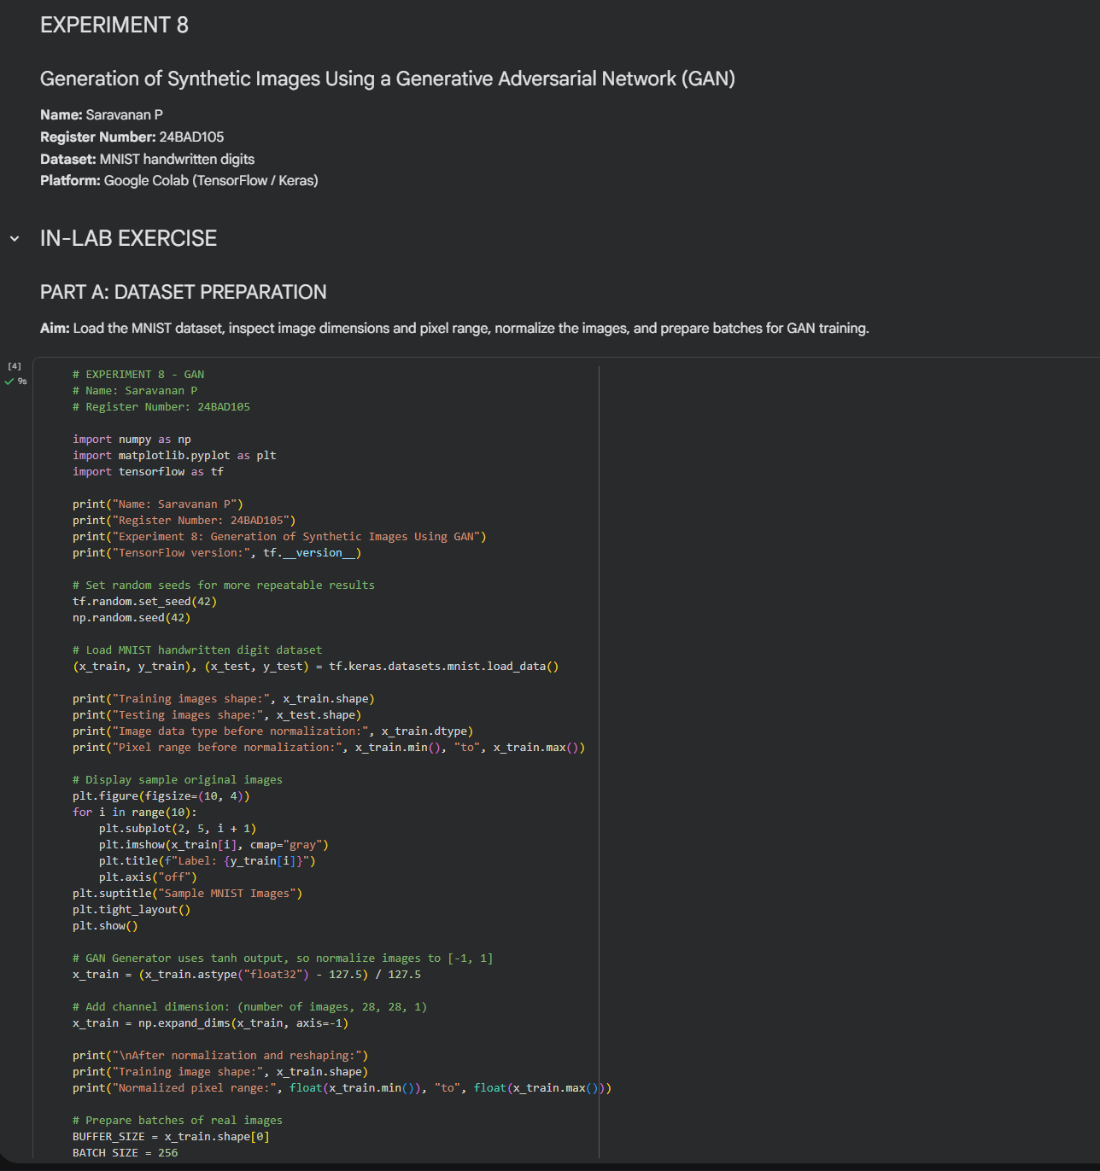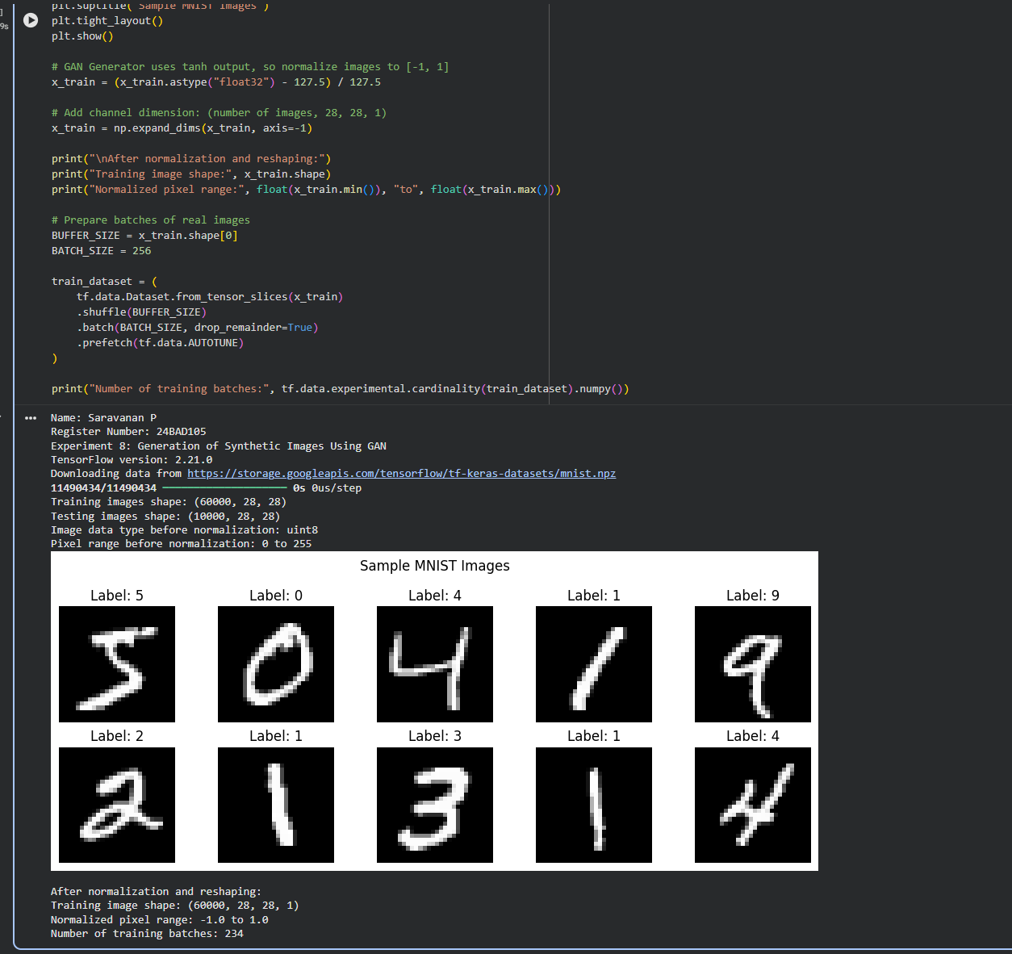

PART B: IMPLEMENTING THE THE GENERATOR AND DISCRIMINATOR
Perform the following tasks:
- Build a Generator model to create synthetic images from random noise vectors.
- Build a Discriminator model to classify images as real or generated.
- Select suitable layers, activation functions, optimizer, and loss function.
- Combine the Generator and Discriminator to construct the GAN.
- Display the model summaries.

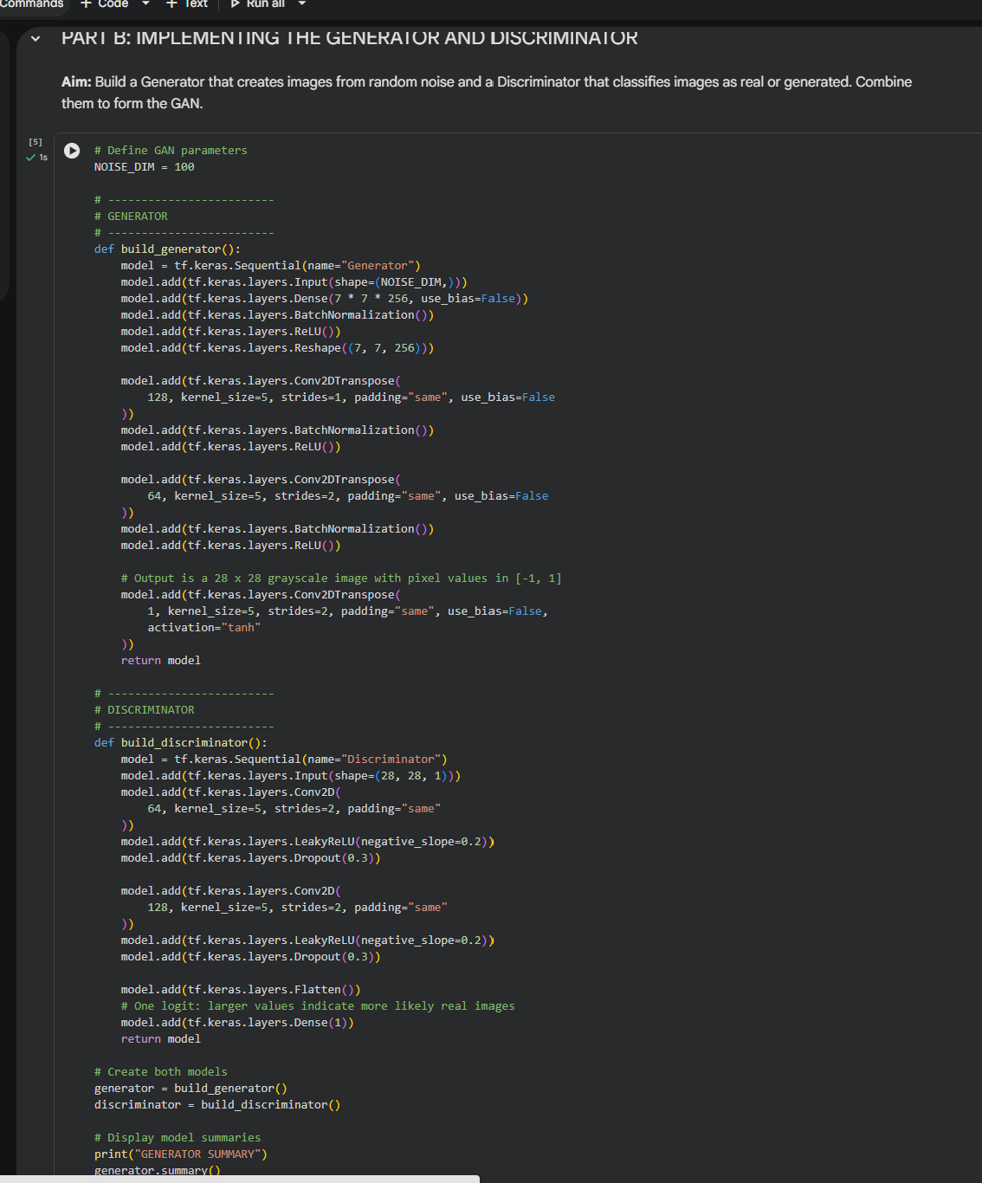

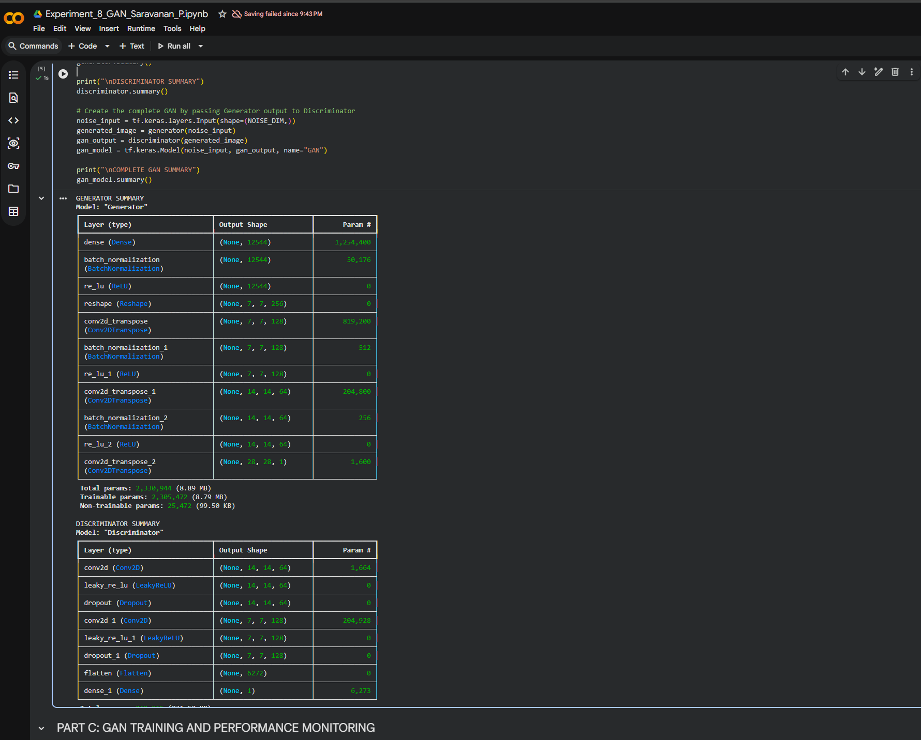

PART C: GAN TRAINING AND PERFORMANCE MONITORING

Perform the following tasks:
- Train the Discriminator using real and generated images.
- Train the Generator to produce realistic images.
- Alternate the training of both models for a suitable number of epochs.
- Record and plot Generator and Discriminator losses.
- Display sample generated images during training.

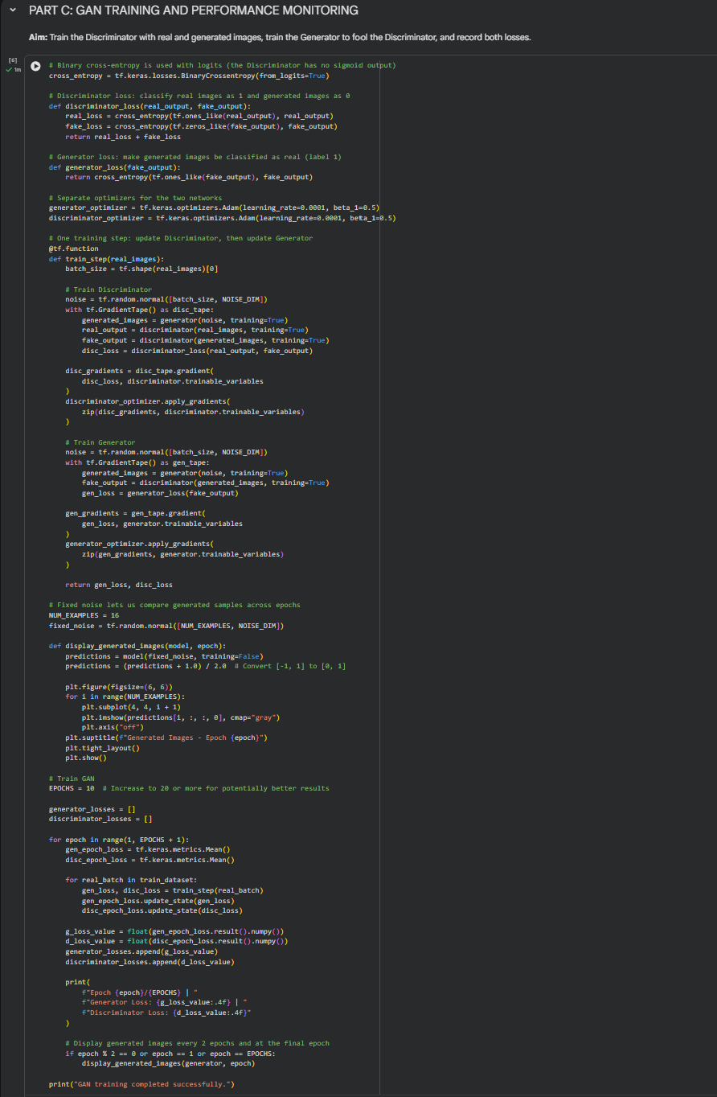

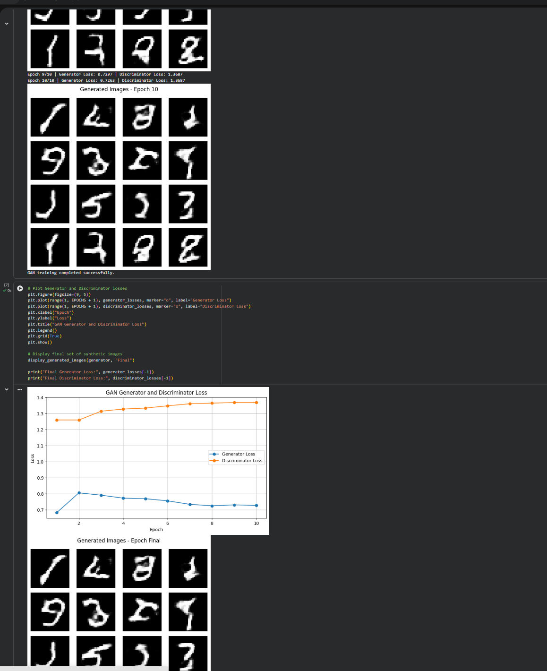

PART D: DIMENSIONALITY REDUCTION, FEATURE VISUALIZATION AND EXPERIMENT MANAGEMENT

Perform the following tasks:
- Provide new movie-review sentences as input to the trained LSTM model.
- Extract latent-space representations of test samples using the trained Encoder.
- Generate synthetic images using the trained Generator.
- Display and compare generated images with original dataset samples.
- Observe the quality, diversity, and recognizability of generated images.
- Document the experiment and upload the notebook to GitHub.
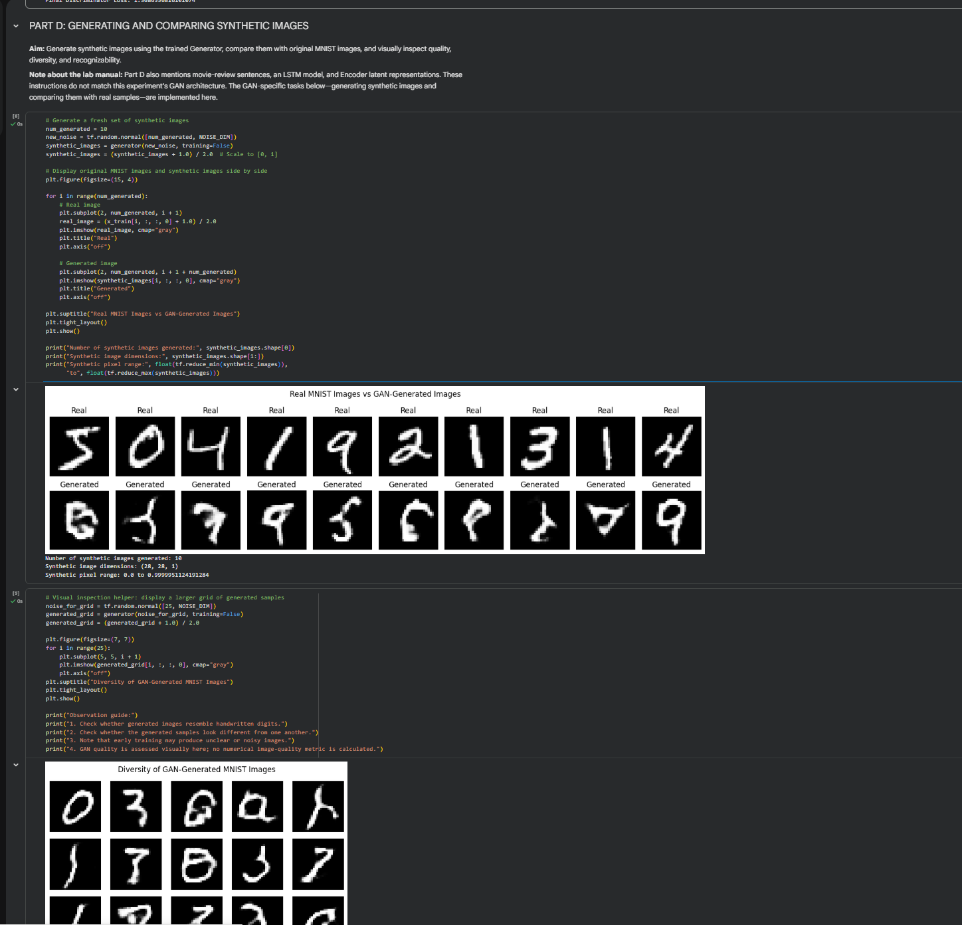

POST-LAB QUESTIONS (PROVIDE BRIEF ANSWERS TO THE FOLLOWING QUESTIONS)

- Discuss how the quality of generated images changes as GAN training progresses. Explain why a GAN may generate repetitive or low-quality images.

As GAN training progresses, the generated images gradually become clearer and more realistic. Initially, images may look like random noise. Later, the Generator learns to produce recognizable images.

GANs may generate repetitive or low-quality images due to:

- Insufficient training.
- Improper balance between Generator and Discriminator.
- Limited training data.
- Mode collapse, where the Generator produces similar images repeatedly.

- Differentiate between the Generator loss and the Discriminator loss.

Generator Loss | Discriminator Loss
Measures the Generator's ability to fool the Discriminator. | Measures the Discriminator's ability to identify real and fake images.
Tries to generate realistic images. | Tries to classify images correctly.
Aims to fool the Discriminator. | Aims to detect generated images.

- Discuss two real-world applications of GANs apart from handwritten digit generation.

- Image Enhancement: GANs are used to improve image resolution, remove noise and restore damaged images.
- Image-to-Image Translation: GANs can convert sketches into realistic images and transform images from one style or condition into another.

ASSESSMENT
Description | Max Marks | Marks Awarded
Pre Lab Exercise | 5
In Lab Exercise | 10
Post Lab Exercise | 5
Viva | 10
Total | 30
Faculty Signature

